Abstract Title
First Author^{1,2}, Second Author¹, Third Author²
¹Affiliations, Address
²Affiliations, Address

Email: corresponding.author@email.address

Keywords: keyword1, keyword2, keyword3
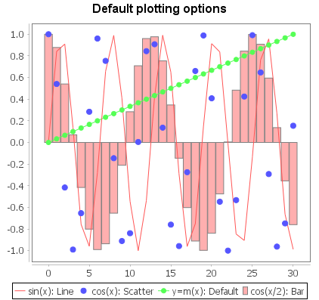

One-page abstract with optional figures[1]. There are no exact restrictions on font size, but generally 10- to 12-point font fits the page nicely. For proper rendering of text, the typeface should either be system default fonts (preferably Windows-available fonts) or the fonts should be embedded into the document itself through the save options. Figures should be placed alongside the text with some padding between the image and the text. The figure should be no wider than half the page to save space. The abstract should use “justified” alignment or left alignment, except in the case of equations or wide figures/tables, in which cases they should be centered.
Figure 1. Sample figure legend. Align figure legend with the figure
Paragraphs should be separated by a blank line. Indents after the first paragraph are optional. Equations may be embedded in line, as in the following sinc function: $sinc\left(x\right)=\sin\left(x\right)/x$ or may be added onto a separate line as in the following Gaussian function:
$$f\left(x,y\right)=Ae^{-\left(\frac{{\left(x-x_{0}\right)}^{2}}{2σ_{x}^{2}}+\frac{{\left(y-y_{0}\right)}^{2}}{2σ_{y}^{2}}\right)}$$

Abstracts must be uploaded as PDFs files. You can export a PDF file directly from Microsoft Word as described in the following link: https://www.windowscentral.com/how-save-microsoft-word-doc-pdf-or-another-file-format. If other file formats are required, please contact info@quantitativebioimaging.com to make arrangements. Abstracts should be no longer than a page, and should be at least 200 words long.

[1] M. Born and E. Wolf, Principles of Optics, 7th ed., vol. 8, no. 2. Cambridge: Cambridge University Press, 1999.

